Sprint 1 Materials
Team A

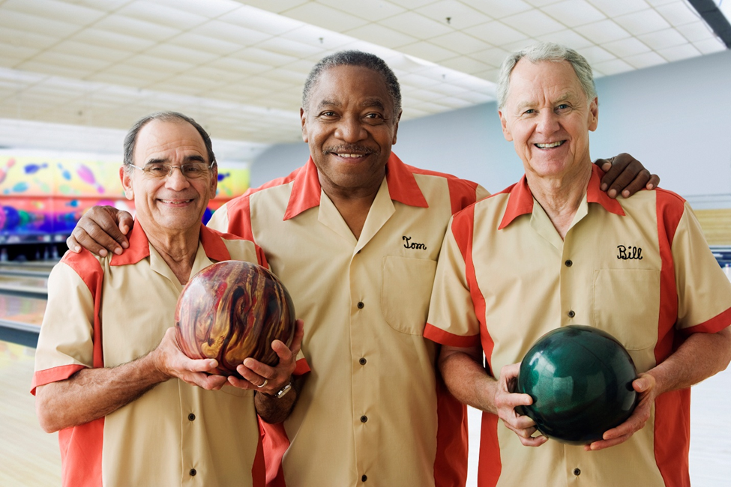

Grant Ashford
Brenden Barber
Leo Cuzela
Ryan Roeling
Sam Scarcelli
Jared Spotts

[Delete all instructions in red before submitting.]

Retrospective Summary
Summarize your retrospective meeting. Discuss what went right and wrong during the sprint, what changes (if any) need to be made regarding procedure, and what adjustments might need to be made to the product backlog. If backlog goals were not met, include an explanation of why not. The summary should be approximately 250 words.

GitHub Release Link
Create a GitHub release of a completely working version of the software and include a link to your release here. Note that some features may not be included if they are scheduled for later sprints, but you must have a minimum viable product (MVP) that a user can give feedback on.
Remember to commit to your repository each time a new feature is added/modified. Items should not be marked as “complete” on your backlog until they have been pushed to your repository.

Product Backlog
Your product backlog contains the list of tasks with their:
- priorities,
- dependencies,
- user story points (an estimate of effort involved from the unitless set {1, 2, 3, 5, 8, 13, 21}), and
- status {not started, in progress, completed}.
It should be updated continually throughout the project. Include the snapshot of the product backlog at the end of the sprint here.
Sprint Backlog
Your sprint backlog is a subset of the product backlog. It includes the list of tasks that were scheduled for the sprint. For each task, it provides:
- user story point value (from the product backlog),
- who assigned to,
- actual time spent, and
- status {not started, in progress, completed}.

It should also contain a summary table that shows the total number of completed user story points for each team member. The summary table should have a column for each sprint completed to date. These will be a factor in your individual contribution assessment.

Burn-down Charts
Include two burn-down charts, one for the sprint and one for the product.
- Burn-down charts should be reported in remaining user story points (not number of tasks). Each burn-down chart should show both the actual and estimated remaining hours of effort over time. Remember that user story points measure the relative estimated effort. They correlate to time spent (but are not equivalent to actual hours/specific units of time.)
- The initial sprint burn-down chart is created from the sprint backlog. It should be updated after each SCRUM meeting based on team member status and feedback. Thus it should contain at least 5 data points (the start of the sprint, 3 SCRUM meetings, and the end of the sprint).
- The product burn-down chart should be updated once during the sprint and again at the end of the sprint. Thus, by the end of the project’s 3 sprints, there should be at least 7 data points on the product burn-down chart (the start of each sprint, the middle of each sprint, and the end of each sprint).

Next Sprint’s SCRUM Meeting Schedule
Include a list of your planned SCRUM meetings for the next sprint. You should have at least 3 SCRUM meetings in each sprint. (This section does not apply for the final sprint.)
Sprint 2:

Date | Time | Location
11/12 (SCRUM Meeting) | 9:45AM - 10:00AM | In class
11/15 | 1:30PM - 5:00PM | Outside of class
11/17 (SCRUM Meeting) | 3:00PM - 3:15PM | Outside of class
11/19 (SCRUM Meeting) | 3:00PM - 5:00PM | Outside of class
11/22 | 1:30PM - 5:00PM | Outside of class

Appendix 1: SCRUM Meeting Agendas and Minutes

SCRUM Meeting 1 for Project 3
Prepared by: Grant Ashford
Meeting Date: 11/3/2025

Meeting Attendees
- Grant Ashford
- Brenden Barber
- Ryan Roeling
- Sam Scarcelli
- Jared Spotts
- Leo Cuzela

Meeting Agenda Items
- Set up the Docker Environment
- Set up project using React.js

Status Update Since Last Meeting
Accomplishments:
- Resubmitted the Project 3 Design Document
- Distributed tasks to all team members

Tasks Completed:
Task Description | Assigned to | Completed? (yes/no)
Set up the Docker Environment | Leo | No
Set up project using React.js | Leo | Yes

Before The Next Meeting
Plans:
- Each team member beginning to do their tasks
- Updating the Manager and Cashier views
- Brainstorm features for customer interface
Task Assignments:
Task Description | Assigned to
Update manager X-report | Grant
Set up the Docker Environment | Leo
Create branch strategies | Brenden
Write appropriate ReadMe | Jared
Seed database with test data | Ryan
Brainstorm thematic features | Sam

Minutes from Previous Meeting
Summarize discussion in paragraph form from the previous meeting (NOT this current meeting).

This is our first SCRUM meeting as a group for Sprint 1, so we can not discuss the previous meeting.
SCRUM Meeting 2 for ProjectName
Prepared by:
Meeting Date:

Meeting Attendees

Meeting Agenda Items

Status Update Since Last Meeting
Accomplishments:

Tasks Completed:
Task Description | Assigned to | Completed? (yes/no)

Before The Next Meeting
Plans:

Task Assignments:
Task Description | Assigned to

Minutes from Previous Meeting
Summarize discussion in paragraph form from the previous meeting (NOT this current meeting).

SCRUM Meeting 3 for ProjectName
Prepared by:
Meeting Date:

Meeting Attendees

Meeting Agenda Items

Status Update Since Last Meeting
Accomplishments:

Tasks Completed:
Task Description | Assigned to | Completed? (yes/no)

Before The Next Meeting
Plans:

Task Assignments:
Task Description | Assigned to

Minutes from Previous Meeting
Summarize discussion in paragraph form from the previous meeting (NOT this current meeting).

Include additional SCRUM Agendas and Minutes on new pages if necessary (if you have more than 3 SCRUM meetings in a sprint).

